Autonomous Vacuum Mouse Droid
David Coleman
Department of Engineering
University Of Central Oklahoma
Michael Nolan
Department of Engineering
University of Central Oklahoma
Abstract-This Project aims to design and produce an autonomous vacuum robot modeled after the mouse droids seen in Star Wars. The robot utilizes an ESP32 controller to control motors, collision detection, and powering the vacuum. The vacuum motor was obtained from a Laresar Elite 5 cordless vacuum. Using a transistor as a switch, the original internal electronics for the vacuum motor were used so that the original battery could be used. The housing for the robot was designed and 3D printed. Upon construction, the robot was able to perform its duty as a vacuum while maintaining basic collision avoidance.
I. Introduction
In the Star Wars franchise there are many robots that roam the galaxy performing hundreds of tasks from being a translator on legs to being a battery with legs that charges something that the writers decided needed charging. One of these robots is called a mouse droid. They can be seen throughout many of the movies as small box like droids that drive around performing a myriad of tasks that are never completely expounded upon in any Star Wars content. One of the theorized tasks is that of janitorial work. For this project we decided to try and make a functional janitorial version of the mouse droid in the form of an autonomous vacuum.
II. Objective
The robot will need several components to be successful. The first and most important is the ability to move independently. This needs to be driven by a system of motors that allows the robot to move both forward and backwards with the ability to turn. Considering this movement, the robot needs the ability to detect and avoid collisions. A simple system is ideal as it is less prone to failure with regards to false positives or blindness. The core component of the project will be the vacuum.
III. Required Components
A. ESP32
For the microcontroller controlling this robot an ESP32 was used. This is a simple programable development board not dissimilar to an Arduino that also has Bluetooth and Wi-Fi capabilities. This was used instead of an Arduino as it can be remotely controlled via Bluetooth from the user’s phone. The ESP32 is also faster than the standard Arduino.
B. DC Motors
To drive the robot 4 DC motors were purchased. DC motors allow for the current to be reversed and change the direction that the motor is spinning. With 4 of these motors the robot gains the ability to turn without moving its center of mass by reversing one side while spinning forward on the other side. This functionality is critical for a robot to navigate tight spaces without having a typical turn radius. The 4 motors also provide the needed power to move the robot as it will be carrying a larger payload consisting of internal control components as well as a separate battery for the vacuum motor.
C. Vacuum Components
Typical vacuums have motors that spin upwards of 100,000 RPM. These motors can be very expensive, and the components attached to the motor shaft have to be manufactured with strength and precision so as not be ripped to shreds by the centrifugal forces generated by the rotation. This RPM is needed to achieve a suction force large enough to pick up small debris and dirt that is on the floor. To acquire one of these motors it is easiest to purchase a cordless vacuum used. For this project a Laresar Elite 5 Cordless Vacuum Cleaner was used. From this vacuum the motor and its driver system were stripped as well as the battery that is used to power the motor.
D. IR Sensors
Object detection was accomplished using the Waveshare Infrared Proximity Sensor. This module uses IR deflection to measure the distance an object is from the front of the sensor. This sensor allowed for analog readings so the device could be calibrated without manual adjustment of the sensor itself.
III. Methodology
The first difficulty in building the Mouse Droid was acquiring a functioning vacuum motor. The Laresar vacuum included a Cinderson H55-LS3410023T-495 DC motor. Upon doing research into Cinderson motors there was no documentation on the motor as to its control methods or requirements. The motor has three wires attached to it. The positive and negative terminals as well as the control terminal. The voltage across the positive and negative was a constant 25.9V during operation. The control wire was found to be a PWM signal at 1 kHz. The motor was simple to control with the ESP32, but during testing it was found that the motor would vary in speed while being controlled by the ESP32 and a variable power supply. This variation in speed was likely caused by issues with grounding. The battery from the vacuum had zero documentation online and had many output pins. These pins did not allow for the use of the battery to supply the needed 25.9V to the motor as the com port to the battery received and sent unknown signals that could not be deciphered. To circumvent this, the electrical internals of the vacuum were used as a driver and power supply for the motor. The vacuum switch was then spliced and electronically controlled by the ESP32 using an NPN transistor.
The DC motors used to drive the robot were controlled via two H-bridge transistor circuits. These allowed for an external power of 5V to be supplied to the motors with a controllable direction of current dictated by the ESP32. Each H-bridge controlled two motors run in parallel to allow the motors on each side of the robot to run in sync.
The IR sensors are mounted at the front of the robot on the left and right sides. This allows for objects on either side of the robot to be detected and avoided. The analog outputs of the IR sensors runs to the ESP32. The output data was found to be inconsistent and varied based on the power supplied to the sensors. To combat this for the startup sequence of the robot 500 readings are taken on each sensor then averaged. Once the average reading for no obstructions is measured the robot determines that any reading less than 10% of the average reading is an obstruction.
The internal body of the robot was designed in three main components, the base plate, air chamber, and motor holder. The base plate was designed with the air intake at the front so that the suction element is as close to any obstruction as possible. It is also designed to allow the wheels to barely extend past the bottom of the base plate to allow the suction element to be as close as possible to the ground. This increases the power of the suction element as it decreases exponentially the further you are from it. The base plate has three protrusions that allow for alignment of the motor holder that rests on top of the base plate. The air chamber is a cylinder with one open face and an entrance on the back side. The air intake entrance is offset from the center so that as the air enters the chamber it does so by rotating around the outside of the chamber. This allows dust particles which are lighter than air to be held against the edge of the chamber as the air is able to move to the motor intake which is suspended in the center of the chamber. The air chamber is glued to the base plate securely holding it in place. The motor itself is heavy enough to hold the holding apparatus down in between the alignment pieces and the air chamber. The filter from the Laresar vacuum has been modified to fit into the air chamber so that no particles enter the motor and damage the impeller.
We are using seven pins on the ESP32. Table 1 shows the pins and their corresponding applications.
Figure 1
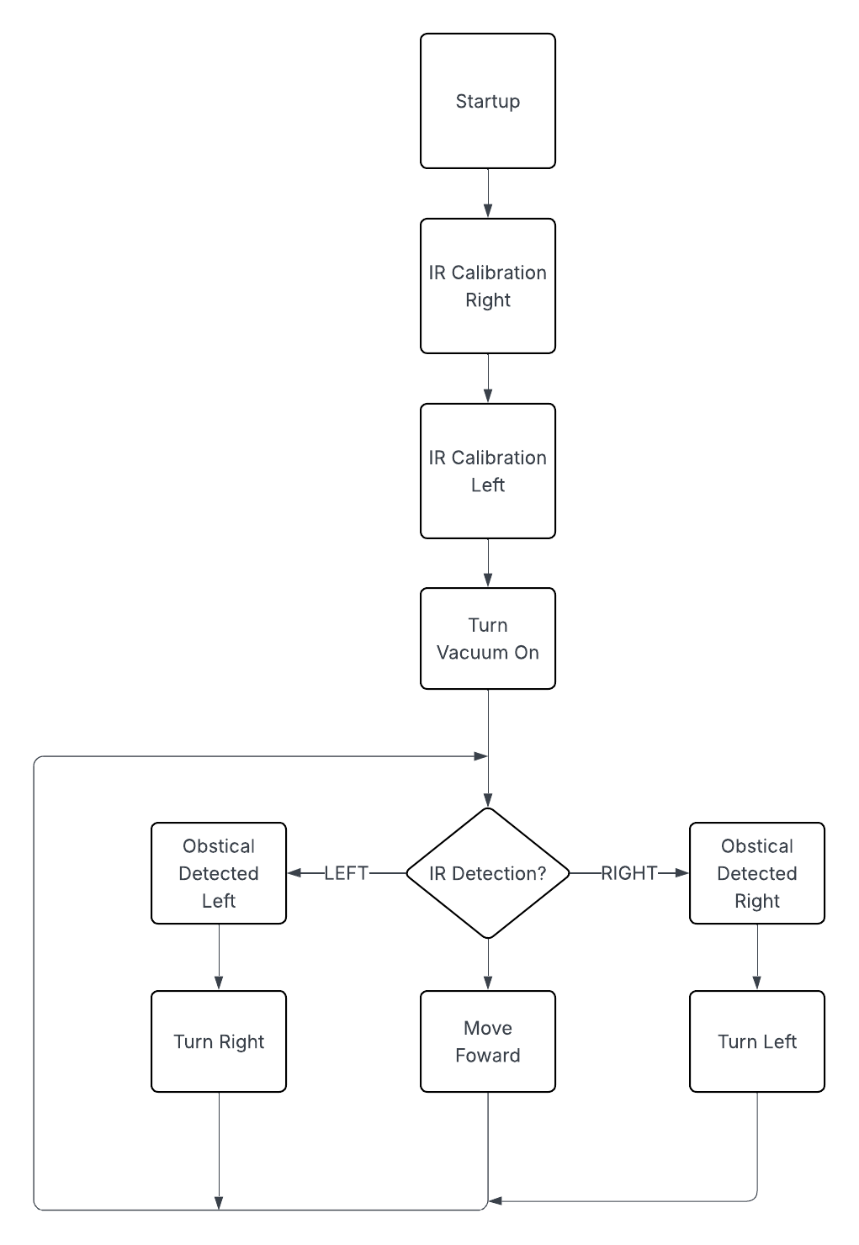
Figure 1 shows the system that the ESP32 follows from start up.
IV. Conclusion
The mouse droid is able to effectively detect walls and other obstructions and effectively turn to avoid them. The vacuum, while not extremely powerful, is able to clean must smaller particles off the floor. With these capabilities the droid has several problems that could be further improved as well as features that could be added. First is better collision avoidance. The IR sensors are placed equidistant from the floor and the top of the robot to catch as many obstructions that fall within these bounds as possible but narrow items will go undetected. This coincides with the next problem of path finding. The robot at the moment runs through the room at random with no cleaning pattern. With better sensors such as dual cameras. A 2D map of the room could be generated as the robot explores and vacuums. Using this map the robot would be able to navigate to un-vacuumed areas to clean them and cease operation once all areas were cleaned. The robot also does not have the capabilities at the moment to operate on carpet. This somewhat limits the areas where the robot is effective. These upgrades would be made possible by switching to a raspberry pi controller instead of the ESP32. Doing this would massively increase the computational power of the robot and allow the addition of several other features.

